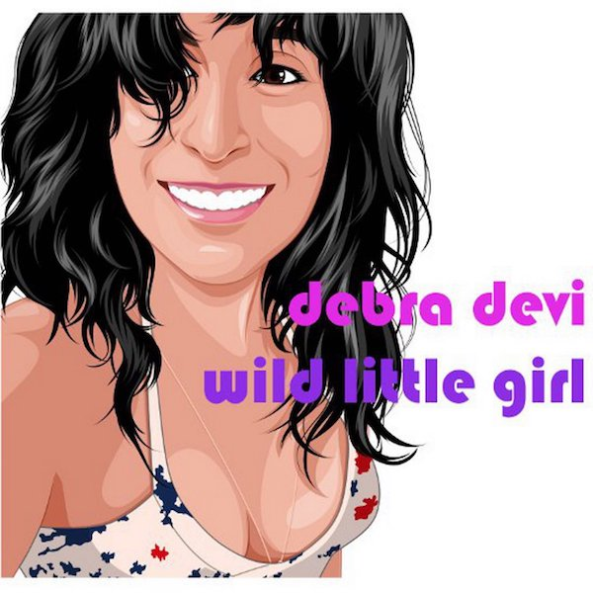
PRESS RELEASE
CONTACT: Patrice Fehlen, September Gurl PR Patrice@septembergurl.com or Debra Devi, debradevi@gmail.com

Rock Artist Debra Devi Releases New EP
Wild Little Girl EP + 4 Music Videos
Release Date: September 8, 2017
Label: True Nature Records

Listen to EP/Watch Videos: https://debradevi.com/wild-little-girl-ep
Wild Little Girl is the new 6-song EP from rock singer/guitarist Debra Devi. Devi has produced four music videos for the EP. They have premiered on The Alternate Root. American Blues Scene, Guitar Girl and The Pop Break.
The Jersey Journal’s Jim Testa writes, “Debra Devi stands out among singer/songwriters as a true triple threat: a gifted songwriter, a powerful singer and an outstanding guitarist. Firmly grounded in blues/rock tradition, Wild Little Girl mixes wistfulness with forcefulness. Every track leaves room for her organic, expansive guitar solos.”
Tracks range from crunchy pop-rock (“Butterfly”) and Gov’t Mule-inspired jamming (“Tired of Waiting”) to pulsing disco-rock (“Stay”), Black Crowes-style sass (“Shake It”) and Devi’s soulful Americana tune “10 Miles to Clarksdale.” Of the latter, a Hardrock Haven live review notes: "’10 Miles to Clarksdale’ is a downcast gem— a story of connecting with a kindred spirit, hopes dashed and the tension of silent longing." Devi’s ‘70s-influenced guitar playing is the thread that weaves throughout – whether she’s playing slide, rhythm or searing lead guitar.
The EP’s title celebrates the freedom girls feel to express themselves and imagine their futures before society's conditioning kicks in, suppressing their creativity, self-confidence and wildness.
"Girls are extremely capable at math, science and the arts, often outperforming boys," Devi explains, "but something happens to girls around age 15. They become increasingly silent in class. They deny their intelligence. I went through that myself, so as a female guitarist I want to encourage girls to be loud, strong and powerful!"
Devi fell in love with electric guitar when she heard the feedback on "Suzie Q" by CCR as a kid. "It was the spookiest thing I'd ever heard, and I couldn't stop listening to it," Devi recalls. Growing up in the Midwest, however, she got the message that only boys played in bands.
In college, though, Devi saw Bonnie Raitt perform and couldn't stifle her own desire to play guitar anymore. She bought a Fender Mustang and moved to NYC. Devi taught herself how to play, joined punk bands and toured the US, Canada and Europe.
When Devi began to sing and write her own songs, her music harkened back to classic '70s rock and pop. "I love the great songs and production from that era, and the idea that a guitar solo should fit a song perfectly," she explains.
Devi's self-produced debut album, Get Free (True Nature Records/Redeye), received raves from Vintage Guitar, Jambase, Marie Claire (Italy), Guitar International and other media for its big classic rock sound, her soulful voice and powerful guitar playing.
Guitar International's editor wrote: “It’s rare that I listen to an album more than once, but after the fifth time through Get Free I was left with only one question: How have I never heard of this artist before?”
Metal Hammer said, "her voice reminds us of Sheryl Crow and PJ Harvey but her guitar playing is reminiscent of the incomparable Jimi Hendrix.'
Devi became a Fender Girl Rock Nation artist and the first female guitarist to record for Guitar World’s popular “Lick of the Day” video lessons app. She played festivals and club dates from Memphis to Montana.
After helping her nephew through a life-threatening health crisis, Devi returned to the studio to produce Wild Little Girl, with drummer John Hummel, bassists Max Feinstein, Dan Grennes and Kevin Hummel; and keyboardists Rob ​Clores (Blues Traveler, The Black Crowes) and Peter Vitalone (Dayna Kurtz).
Based in Jersey City, Devi and her band are playing clubs and festivals along the East Coast, and opening for national acts like Devon Allman and Nikki Hall. Live, says New York Music Daily, "Devi leads a ferocious guitar-driven band equally adept at sprawling psychedelic jams and terse, soulful rockers."
Devi is the author of the blues glossary The Language of the Blues: From Alcorub to Zuzu (foreword by Dr. John), which won the ASCAP Deems Taylor and is blurbed by Bonnie Raitt and Joe Bonamassa.
Wild Little Girl EP Track List
1) Butterfly - A masochistic-yet-triumphant love song from the perspective of a shy girl messing around with the kind of guy who attracts lots of beautiful women. She knows it won't last, but chooses to fly into the flame. In doing so, she discovers her own huge passion for life.
2) Shake It - the tongue-in-cheek tale of a guy trying to sweet-talk his girlfriend into become a stripper to support his music-making habit. "You need a little glamour," he tells her, "if you wanna be my girl." "Shake It" skewers the pressure women face to support mens’ dreams at the expense of their own, and to conform to conventional ideals of sexiness and beauty.
3) Tired of Waiting - Devi's odd-time-signature ode to sexual frustration is hypnotic, heavy and bluesy, slipping effortlessly between 7/8 and 4/4 time with a Gov't Mule vibe, while Devi sings about bolting from a relationship gone cold.
4) 10 Miles to Clarksdale - Devi’s hymn to the stark, lonely beauty of the Mississippi Delta features soulful backgrounds from Anthony Krizan. Krizan appears in the video, which includes stunning drone footage of Little Zion Church in Greenwood MS shot by Sidemen: Long Road to Glory director Scott Rosenbaum.
5) Stay - inspired by the story of a devastated friend who lost his beautiful and talented young wife to cancer, "Stay" is Wild Little Girl's uplifting, disco-driven closer, and Devi's call for the power of love to conquer all, even a broken heart.
6) Tired of Waiting (live) - bonus live track recorded at Arlene's Grocery in NYC, available on the EP digital download only.
Wild Little Girl EP Credits
All songs written and produced by Debra Devi (La Que Sabe Music/ASCAP)

1) Butterfly
Guitars, lead and background vocals– Debra Devi
Bass, background vocals – Max Feinstein
Drums, tambourine – John Hummel
Keys – Rob Clores

2) Shake It
Guitars, lead and background vocals– Debra Devi
Bass – Max Feinstein
Background Vocals - Max Feinstein, Anthony Krizan, John Roccesano
Drums, tambourine – John Hummel
Keys – Rob Clores

3) Tired of Waiting
Guitars, lead and background vocals – Debra Devi
Bass, background vocals – Max Feinstein
Drums, congas – John Hummel
Keys – Rob Clores

4) 10 Miles to Clarksdale
Guitars, lead and background vocals – Debra Devi
Bass - Dan Grennes
Background vocals - Anthony Krizan
Drums, tambourine – John Hummel
Keys – Wayne Dorell

5) Stay
Guitars, lead and background vocals – Debra Devi
Bass - Kevin Hummel
Drums, tambourine – John Hummel
Keys – Peter Vitalone

6) Tired of Waiting (live)
Guitars, lead and background vocals– Debra Devi
Bass, background vocals – Max Feinstein
Drums, tambourine – John Hummel
Keys – Peter Vitalone

Recorded at Studio A by Tom Camuso (drums, lead vocals), IIWII by Billy Perez (guitars), Silver Horse Sound by John Roccesano (guitars, background vocals), and Sonic Boom Studios by Anthony Krizan (background vocals on "10 Miles to Clarksdale" and “Shake It”), except "Tired of Waiting (live)" recorded at Arlene's Grocery NYC

Mixed by Wayne Dorell at The Velvet Owl; except "Tired of Waiting (live)" mixed by John Roccesano at Silver Horse Sound

Mastered by Fred Kevorkian at Avatar Studios

